Multi-objective assessment of stakeholder-defined portfolio of management options clarifies trade-offs in an active local water planning process
Claire Kouba
2025-11-12

Abstract
In the rural American West, water needs of agriculture and ecosystems are often in competition. Furthermore, in places with interconnected surface- and groundwater systems, stream-aquifer exchange increases the difficulty of tracking impacts of diverse water users on each other and on the system as a whole. Hydrologic models can estimate the impacts of water uses and management actions on groundwater elevation and streamflow, but may provide overwhelming amounts of information and/or may be challenging for stakeholders to interpret. In this study, we address these challenges and aim to increase utility of hydrologic model results for a case study jurisdiction in northern California, which is in the process of implementing a long-term Groundwater Sustainability Plan (GSP). We developed a summary statistic or proxy for each of the three primary policy considerations in the GSP (environmental, agricultural, and project cost). We then used them to summarize the results of 25 management scenarios developed for the GSP, which were simulated using an existing integrated surface- and groundwater model. We found that a trade-off in benefits for fish and farms was evident in every category of infrastructure investment (a proxy for project cost), though greater infrastructure investment can achieve some reductions in this trade-off. Additionally, although the GSP management priorities emphasized infrastructure investments, both infrastructure-based and regulatory approaches fell within the Pareto-optimal set of management options under a strict application of these objective functions. Finally, regarding regulatory actions, management interventions targeted at low-flow periods produced a more efficient gain in environmental flow value per cost in agricultural productivity. This work demonstrates that basin-specific, stakeholder-informed objective functions can increase stakeholder-salience of existing hydrologic model results, and can help clarify trade-offs in ongoing local water planning efforts.

1 Introduction
Climate adaptation in the water sector, in its many facets - e.g., securing water and food supplies, updating infrastructure to reduce flood and drought risk, and preserving ecosystem function - is often most effective when implemented at the local level (e.g., Van Steenbergen 2006). However, local water managers face a complex regulatory landscape and serve diverse stakeholders, and typically have unmet knowledge needs (Bork and Hirokawa 2021; Nordgren, Stults, and Meerow 2016). Academic hydrologists have many tools to fill such knowledge gaps; however, when seeking broadly-relevant findings, they commonly avoid time-consuming engagement with specific local water organizations, which can reduce the utility of the resulting research to the relevant decisionmakers (Freeman 2000). In this study, we take advantage of the authors’ involvement with an existing water resource planning process, and a previously-developed integrated surface- and groundwater model, to test the utility of introducing quantitative objective functions into the public prioritization of groundwater management alternatives in a case study jurisdiction.
In our study area, the intermontane rural Scott Valley in northern California (Figure 1), the local government and public stakeholders spent three years (2018-2021) developing a plan for the long-term use of groundwater (a Groundwater Sustainability Plan or GSP). In that process, they evaluated dozens of potential water management scenarios (Siskiyou County 2021). In public meetings, different objectives were often championed by individual stakeholders or interest groups. An integrated hydrologic model, the Scott Valley Integrated Hydrologic Model, or SVIHM (Tolley, Foglia, and Harter 2019), was available to support this policy-making process. The numerical streamflow results of simulated management scenarios drove decision-making, but discussions on the balancing of multiple objectives were typically qualitative. In effect, the optimization framework used to arrive at the ultimate list of management priorities was implicit, and the conceptual weight given to different objectives varied between stakeholders.
Differences between stakeholders in what is considered an acceptable trade-off are common in policy decisions (Monarchi, Kisiel, and Duckstein 1973). Consequently, multi-objective optimization studies often avoid proposing a single optimal solution; instead they identify a Pareto-optimal or non-inferior set of options, which can clarify the unavoidable trade-offs in the performance of various system objectives (e.g., Cohon and Marks 1973). Methods for finding the non-inferior set often involve uniform or randomized initial sampling of the decision space (e.g., Monarchi, Kisiel, and Duckstein 1973; Yeh and Becker 1982; Kapelan, Savic, and Walters 2005). In the case of the Scott Valley GSP, the management actions considered by stakeholders covered a wide range of decision variables (e.g., land use changes in a variety of spatial configurations, technology and/or infrastructure investment, and regulatory interventions on a range of growing season dates). Because a full randomized sampling of this decision space would be computationally prohibitive, this study instead focused on a set of simulated management scenarios that were effectively pre-screened by stakeholders for feasibility in the landscape of existing land uses and political dynamics.
In this study we developed numerical representations of three objectives: 1) maximizing specific environmental flows, 2) minimizing reduction in agricultural water supplies, and 3) minimizing new infrastructure costs. With these, we quantitatively summarized the management benefits and trade-offs within the existing suite of several dozen stakeholder-proposed management scenarios. We hypothesized that an explicit objective function framework would yield different prioritization of management actions than the set agreed upon in public meetings (as recorded in the 2021 GSP) and potentially new insights about the holistic management option landscape.
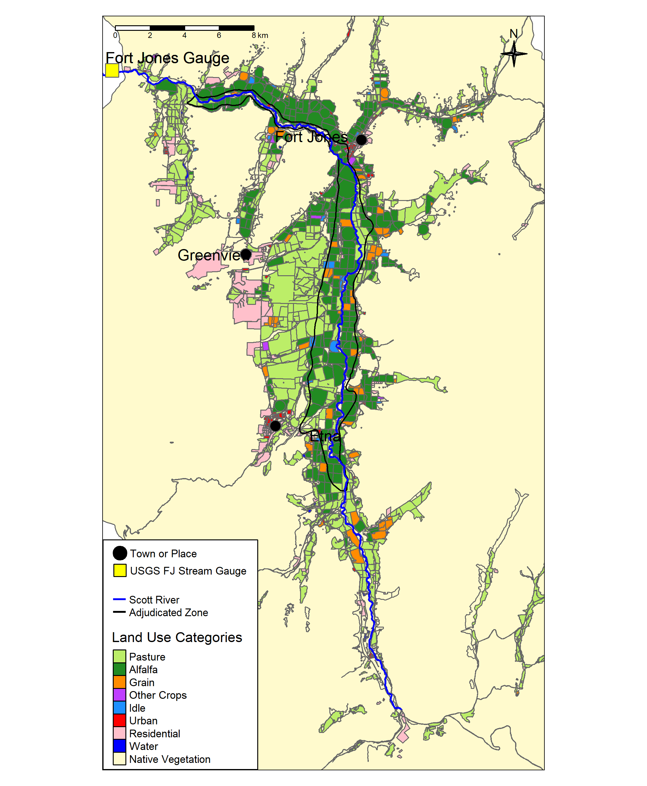
Figure 1: The Scott River flows south to north through Scott Valley before flowing through a canyon and joining the Klamath River. Land uses in the cultivated areas of the Scott River watershed are shown (adapted from the 2016 DWR Land Use Survey), as well as the location of several communities and the Fort Jones streamflow gauge (USGS Station ID 11519500).

2 Background: Case study and GSP development

2.1 Hydrography and climate
The Scott River drains a 2,109 km² (814 square mile) intermontane watershed known as Scott Valley, with forested uplands and a largely agricultural valley floor (Figure 1) overlying an alluvial aquifer up to 79 m (260 ft) thick (SWRCB 1975; Mack 1958). A key stream gauge (USGS Station ID 11519500, or the Fort Jones Gauge or FJ Gauge) is located downstream of the watershed’s cultivated areas (Figure 1).
Scott Valley has a Mediterranean precipitation regime with distinctive seasons of cold, wet winters and warm, dry summers (Figure 2, panels A and B). Winter storms (October-April) and melting mountain snowpack (April-July) generate streamflow during the wet and growing seasons. As a result, the Scott River and tributary streams experience seasonal high and low flows (Figure 2, panel C).
Streams and groundwater are highly interconnected in the Scott River watershed (Tolley, Foglia, and Harter 2019). Tributary streams and the Scott River are a source of recharge to the aquifer, and groundwater discharge sustains streamflow in some areas, especially during the dry season of August-October or November. Some streams are ephemeral, i.e., some tributaries or reaches of the Scott River go dry in average-to-dry water years (Tolley, Foglia, and Harter 2019).
## png
## 2
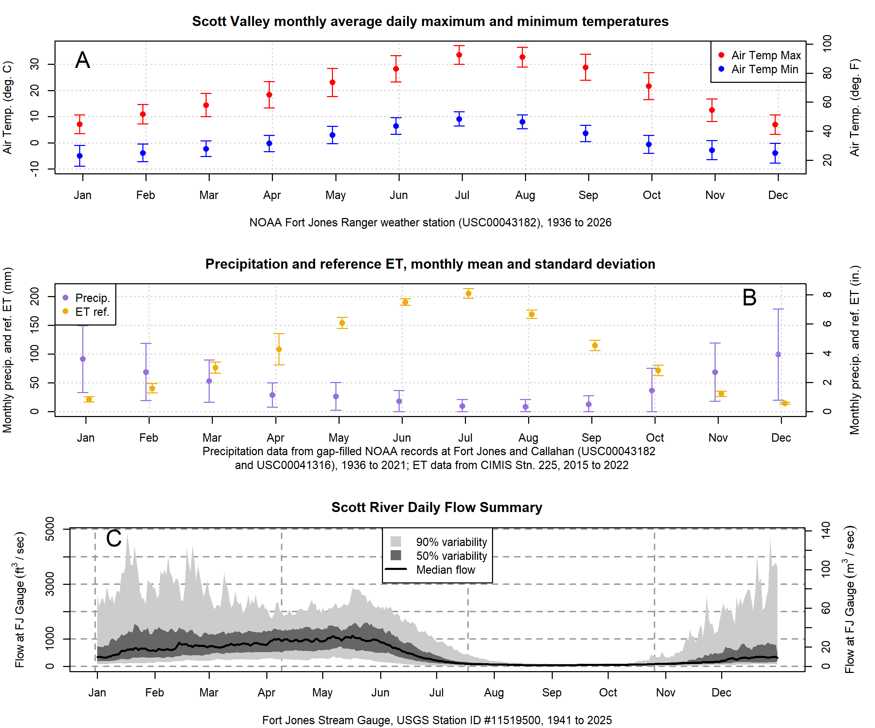
Figure 2: Summary of temperature (Panel A), rainfall and reference evapotranspiration (Panel B), and daily streamflow values (Panel C) in Scott Valley. For precipitation, regression relationships between the Callahan and Fort Jones weather station records and the records of NOAA stations in Greenview, Etna, and Yreka (USC00042899, USC00043614, USC00049866, and US1CASK0005) were used to predict missing values (i.e., fill gaps) in the Callahan and Fort Jones records; the daily mean of the two stations was used as the final precipitation record for purposes of this figure and the SVIHM precipitation input.

2.2 Land and water uses
Because the watershed is undammed, managers and water users influence Scott River flow primarily via diversion of surface waters or pumping of groundwater. Consequently the most powerful tool available to manage Scott River water flow is regulation of land use and thus water demand (Siskiyou County 2021).
About two thirds of the land within the Scott River watershed is under private ownership with the remaining area managed by the Quartz Valley Indian Reservation, the United States (U.S.) Department of the Interior Bureau of Land Management (BLM) and U.S. Forest Service (USFS) (Harter and Hines 2008). On the valley floor, according to land use surveys conducted by the California Department of Water Resources (DWR 2017), half of the area overlying the alluvial aquifer is covered by irrigated agriculture, notably pasture for cattle and an alfalfa/grain rotation (Figure 1; Table 1).
Historically, local regulation of land use has focused on maintaining the rural and agricultural character of Scott Valley (Scott Valley Area Plan Committee 1980). However, during recent declarations of emergency drought conditions, water use has been temporarily curtailed to preserve flows for aquatic species (SWRCB 2021; “Establishment of Minimum Instream Flow Requirements, Curtailment Authority, and Information Order Authority in the Scott River and Shasta River Watersheds” 2024; STATE WATER RESOURCES CONTROL BOARD 2024).
Table 1: Acreage and percent of total Basin area covered by generalized land uses as reported in DWR's 2016 land use survey.
Land Use Category | Acres | Percent of Watershed Area
Native Vegetation | 378,005 | 89.4
Pasture | 20,483 | 4.8
Alfalfa | 13,931 | 3.3
Residential | 4,908 | 1.2
Grain | 2,152 | 0.5
Urban | 1,584 | 0.4
Water | 1,220 | 0.3
Idle | 454 | 0.1
Other Crops | 175 | 0.0

2.2.1 Environmental stream flows
Sufficient environmental flows, varying by season, are necessary to the survival of vulnerable species in the Scott River watershed (Scott River Watershed Council 2018). Coho salmon (Oncorhynchus kisutch) in Scott Valley belong to the Southern Oregon / Northern California Coast (SONCC) Evolutionarily Significant Unit (ESU), and were listed as threatened under the federal and California Endangered Species Acts (ESAs) in 1997 and 2005, respectively. Statewide coho populations have declined by an estimated >90% since the 1940s (Brown, Moyle, and Yoshiyama 1994).
To complete their life cycle, coho salmon require several key functional flows in the Scott Valley freshwater stream system (Kouba et al. 2025), including the following:
- Fall flows, increasing after the dry season in response to early wet season storms, that occur early enough to provide adult fall-run spawners access to preferred spawning reaches;
- Flows providing habitat for rearing juvenile salmon for their ~12-15 months of freshwater residence; and
- Sufficient flow in the spring for yearling smolts to migrate to the ocean.
Different functional flows are needed by other fish, such as Chinook (Kouba et al. 2025); as well other species, such as cottonwood trees, which require flood-stage flows to disperse their seeds (Mahoney and Rood 1998); but in this work we focus on coho salmon as a straightforward example in developing an environmental objective function. Alternative objective function formulations are discussed in later sections.

2.2.2 Agricultural water demand
Agricultural water demand in Scott Valley has been simulated for a historical model period of Oct. 1, 1990 to Sept. 30, 2025, using the calibrated Scott Valley Integrated Hydrologic Model (SVIHM) (Harter and Hines 2008; Foglia et al. 2013; Tolley, Foglia, and Harter 2019). Water demand for crops and native vegetation (evapotranspiration, or ET, in Figure 3) and applied irrigation volumes (diverted surface water and pumped groundwater, noted as SW and GW Irrigation in Figure 3) are highest in the late summer. Annual crop ET and irrigation demand is relatively stable year to year while precipitation, and thus recharge to groundwater, are more variable (Figure 4).
In this intermontane valley, the growing season is constrained by hard frosts, and begins in March-April and extends through September-October. Both of the primary crops (alfalfa and pasture) are perennial, and will continue producing through the growing season as long as soil moisture is available. Alfalfa cultivation since the 1970s has commonly involved three to four harvests (referred to as cuttings) per growing season; it is typically irrigated several times and then left to dry before cutting (Tolley, Foglia, and Harter 2019).
The tension between agricultural and ecological water demands is highest at the end of the dry season, when groundwater elevations and surface flows are at their lowest, crop demand remains high, and anadromous fish require access to spawning habitat. The management of these fall flows was a central concern of GSP development in 2018-2021.
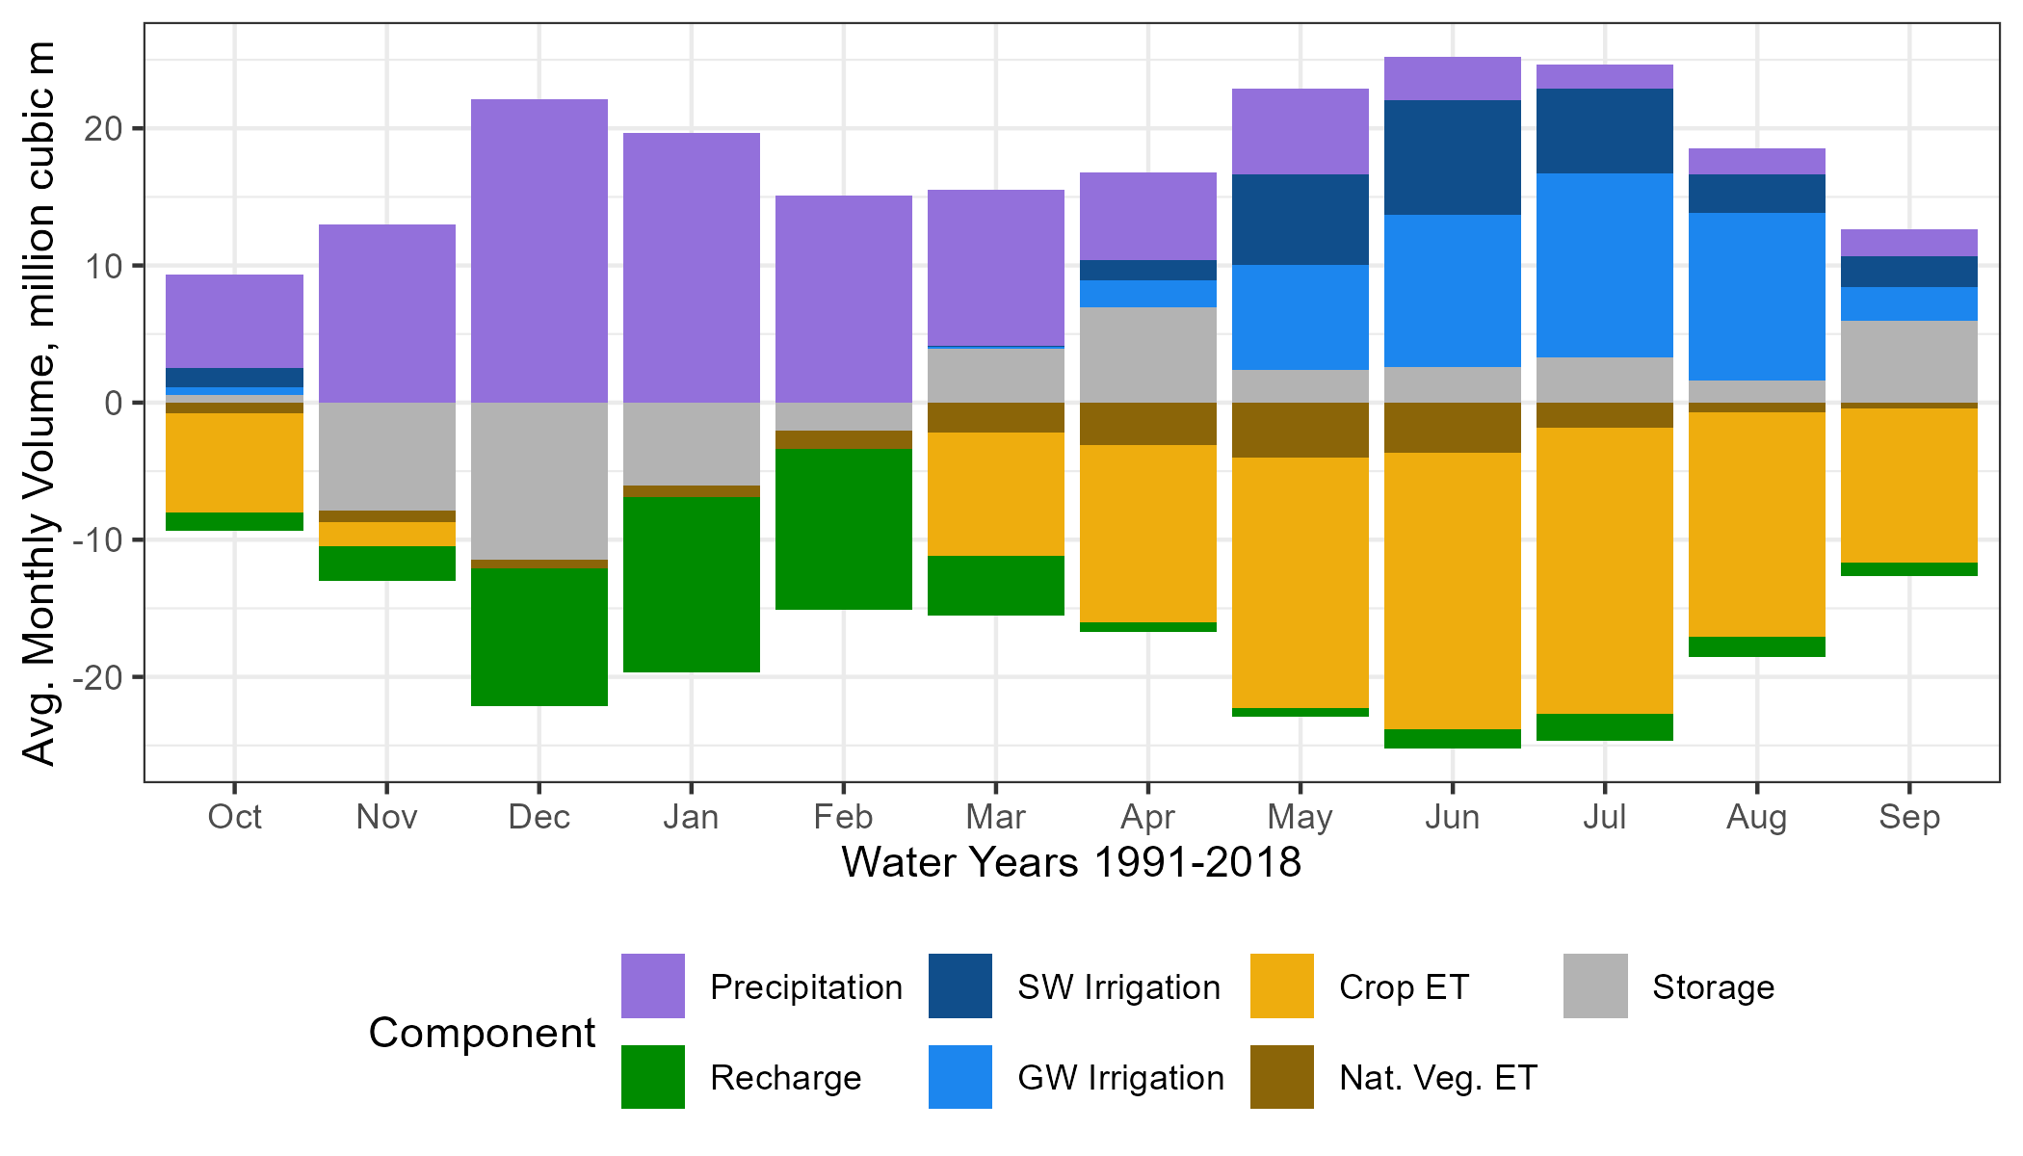
Figure 3: Average monthly water budget for the soil zone, simulated with SVIHM, for the model simulation period (water years 1991-2018). Positive and negative values indicate average net monthly fluxes into and out of the soil zone, respectively.
## png
## 2
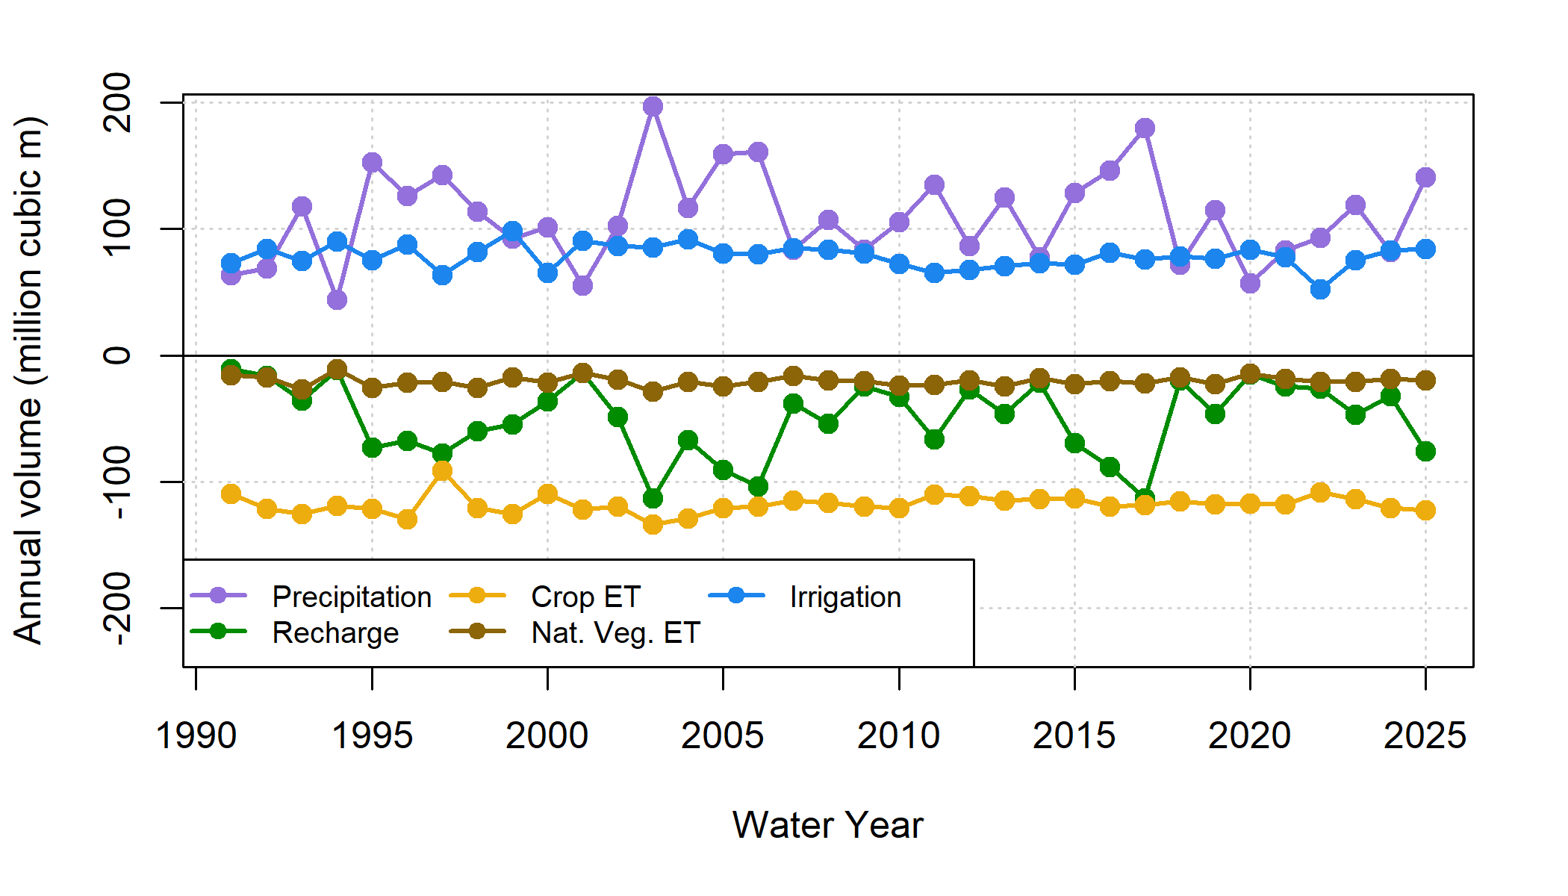
Figure 4: Annual values for inflowing (positive) and outflowing (negative) water budget components in the SVIHM soil zone (historical basecase simulation). Irrigation refers to both groundwater and surface water sources; Recharge refers to water percolating through the soil column and recharging the aquifer below. Both crop ET and ET from native vegetation remain relatively stable year to year, while precipitation inputs, and thus recharge to the aquifer, have higher interannual variability.

2.3 GSP development
The Scott Valley Groundwater Sustainability Plan (GSP) was developed by the Siskiyou County Flood Control and Water Conservation District, which is the designated Groundwater Sustainability Agency (GSA) charged by the state of California to sustainably manage local groundwater resources pursuant to the Sustainable Groundwater Management Act (SGMA) of 2014. GSP development took place between 2018 and 2021, and was guided by discussions in the monthly public meetings of an Advisory Committee composed of nine local stakeholders. Technical analyses supporting the public meeting deliberations and GSP policies were provided by several technical experts, including the authors of this study (Siskiyou County 2021).
SGMA requires each local GSA to define sustainability in the negative, by quantifying and then avoiding “undesirable results” that would be “significant and unreasonable”. The central undesirable result in Scott Valley is streamflow depletion due to groundwater pumping. Consequently, a central challenge of GSP development was deciding the amount of (estimated) streamflow depletion that the GSA should aim to reverse, accounting for environmental water demand and what degree of water security was owed to local agriculture.
During GSP development, the authors of this study simulated dozens of land and water use scenarios to facilitate the comparison of management alternatives that could reduce streamflow depletion to various degrees. Simulations were conducted with a spatially explicit, integrated surface water-groundwater model (Tolley, Foglia, and Harter 2019), as described below.

3 Methods
We developed two objective functions and one categorical objective proxy to evaluate the management scenarios developed for the GSP. The three objectives were:
- maximize specific environmental flows,
- maintain current levels of agricultural productivity (represented as minimizing reduction in agricultural water use), and
- minimize new infrastructure costs (represented as a categorical infrastructure/feasibility proxy) (Table 2).
We then applied these to the results of each simulated management scenario, found the Pareto-optimal set of scenarios, and compared them to the prioritization of management actions adopted in the GSP (Siskiyou County 2021).
Table 2: Management objectives and description of objective functions applied to summarize scenario performance.
Management Objective | Objective Function
Maximize specific environmental flows | Hydrologic Benefit function, based on flow metrics empirically correlated with coho salmon reproduction rates (higher values preferred)
Minimize reduction of agricultural water use | Crop ET volume over model domain (higher values preferred)
Minimize new infrastructure investment | Feasibility category of 1-4 (lower values preferred)

3.1 Objective functions

3.1.1 Hydrologic Benefit function
In previous work (Kouba et al. 2025), we showed that the relative degree to which a given water year provided ecological services needed by coho salmon can be empirically estimated using a Hydrologic Benefit (HB) function, which is represented as a linear combination of annual functional flow values. Functional flows are set of streamflow metrics related to the timing, amplitude, and duration of flow phenomena (Yarnell et al. 2015; Patterson et al. 2020; Carpenter 2024) were weighted according to their power to predict coho outcomes, such as smolt production or smolt production normalized per female spawner. The combination of these weighted metrics can be interpreted as a prediction of coho salmon reproduction due to hydrologic factors. Importantly, the HB function selected for this exercise only explains about 60% of variation in observed smolt abundance, and the remaining 40% of variation is assumed related to other life conditions, e.g., number of returning spawners, water quality, food resources, and internal fishery population dynamics.
Specifically, the HB function predicts a higher number of coho smolt produced (coho smolt-equivalent) is related to higher fall flows during a cohort’s parents’ spawning, lower fall flows during a cohort’s time as overwintering yearlings, and a slower spring recession (see intercept and coefficient values in Table 3).
language on selecting smolt based on hydro only predictors, and only for coho
Table 3: Coefficients for the Hydrologic Benefit function, an emperical estimate of ecological services provided to coho salmon by specific functional flows. The predicted value is in units of log10(coho smolt) produced due to hydrologic factors.
Predictor | Value | Greater Hydrologic Benefit value associated with
Intercept | 1.944 | (Intercept)
w1_Wet_BFL_Mag_50 | -0.181 | Smaller wet season baseflows (as eggs and hatchlings)
s1_SP_ROC_Max | -0.041 | Slower max. rate of change, spring recession (as outmigrating smolt)
The HB function was formulated based on functional flow metrics of the observed daily average flow record of the FJ gauge ($FJ_{obs}$). One key result of the historical basecase scenario is a simulated estimate of the historical FJ gauge record ($FJ_{sim, basecase}$); however, although SVIHM was extensively calibrated (Tolley, Foglia, and Harter 2019), because all models involve structural simplifications of a full-scale watershed, $FJ_{sim, basecase}$ sometimes over- or under-estimates $FJ_{obs}$. As a result of these differences, HB values calculated from flow metrics of $FJ_{sim, basecase}$ tend to be higher than HB values derived from $FJ_{obs}$ by a mean of 4.5 coho spf-equiv.
To control for this, all basecase HB values used in this study are derived from $FJ_{sim, basecase}$, making them directly comparable to HB values derived from the simulated FJ flow records in the hypothetical management scenarios.

3.1.2 ET volume function (agricultural benefit proxy)
The annual crop ET volume, which is explicitly simulated in the hydrologic model, is used here as a proxy for agricultural productivity. Other options for framing the agricultural water use objective function include crop yields and total revenue, which may be of greater concern to stakeholders; however, annual crop ET was selected because the impacts of reduced water availability on yield or revenue will likely vary by grower and over time.
Additionally, for alfalfa and pasture and grain?, which continue growing as long as water is available, a strong relationship between crop ET and yield is assumed (Carter and Sheaffer 1983). The assumption that crop ET is consistently related to yield or revenue breaks down for a management scenario that includes changing crops; this is explored further in the Discussion section. But on the merits of these options, annual crop ET was selected to represent agricultural benefit.

3.1.3 Proxy for scenario infrastructure investment
In lieu of detailed cost estimates or feasibility studies, we chose to group management alternatives in qualitative categories approximating the degree of new infrastructure investment needed in each alternative. The categories describing project feasibility and timeframe are as follows:
- No feasibility barriers (basecase; maintain current practices)
- Implementable with current infrastructure
- Requires new infrastructure that would take 1-2 years to build
- Requires new infrastructure that would take 3-5 years to build
- Requires new infrastructure that would take 5+ years to build
This reflects the first-order understanding that, for example, building a reservoir (assigned to category 4) will take more effort and resources in terms of permitting and construction than widespread installation of highly efficient irrigation systems (assigned to category 2). See Table 5 for full list of assigned categories.

3.2 Analyses of objective function values

3.2.1 Trade-off efficiency
Combining two of the three objectives, scenarios can also be compared in terms of environmental benefit per agricultural cost. This “trade-off efficiency” of a management scenario, or $Eff scen$, is unitless (i.e., it has units of smolt-equiv. per smolt-equiv. / million m³ per million m³) (see equations below).
$$HB_{avg}=\frac{1}{n_{wy}}\sum_{i=wy_{1}}^{wy_{n}}{HB_{wy_{i}}}$$
$$ET_{avg}=\frac{1}{n_{wy}}\sum_{i=wy_{1}}^{wy_{n}}{Crop ET_{annual, wy_{i}}}$$
$$Eff_{scen}=\frac{\left(HB_{avg, scen}-HB_{avg, basecase}\right)/HB_{avg, basecase}}{-1*\left(ET_{avg, scen}-ET_{avg, basecase}\right)/ET_{avg, basecase}}$$

3.2.2 Pareto-optimal set of management actions
After calculating the objective function values for each scenario, we applied a simple algorithm to identify the Pareto-optimal set of scenarios (ParetoVilfredoCours1896?). A scenario was identified as Pareto-optimal if there were no other scenarios that performed better in two or more objectives. In other words, the Pareto-optimal set is the collection of scenarios in which it is not possible to improve on one objective without reducing performance in another objective. By definition, this set cannot identify a single best scenario or evaluate trade-offs between objectives; we use it here to identify obviously suboptimal scenarios.

3.3 Hydrologic model summary
The Scott Valley Integrated Hydrologic Model (SVIHM) (2019) is a surface and groundwater model driven by tributary stream inflows, precipitation, and reference evapotranspiration (ET₀). Like all models, it does not perfectly reproduce historical observations, but it successfully captures key watershed-scale hydrologic phenomena that can be used to evaluate potential outcomes of specific management actions.
The SVIHM is composed of three cascading sub-models. First, complete daily records of tributary stream inflow are generated using a statistical streamflow regression model, in which the continuous Fort Jones record was used to predict missing values in the daily flow records of 12 major tributaries (Foglia et al. 2013). Second, a custom-built soil water budget model simulated irrigation demand, irrigation applied (surface and groundwater), ET and percolation to aquifer calculated on a field-by-field, daily time step basis. This model simulates individual irrigation applications and assumes the farmer has perfect foresight of daily irrigation demand. Finally, the boundary conditions of stream inflow, aquifer recharge, and groundwater extraction are used to drive an integrated groundwater-surface water model using MODFLOW; stream-aquifer flux and surface flow routing was simulated using the MODFLOW SFR package (Tolley, Foglia, and Harter 2019). Add text re: Leland’s updates to SVIHM? Bah, should I rerun everything using the latest model version?
For GSP development, SVIHM was used extensively to perform what-if scenarios using the historic climate and land use forcing period, covering 1991-2018. (For purposes of this study, the model period has been extended through Sept. 30, 2025.) Scenario simulations repeat the calibrated historical basecase simulation of SVIHM while varying specific changes in SVIHM boundary conditions (BCs). The set of changes in the BCs of a particular scenario represent specific changes in land use, irrigation management, climate, water management rules, etc. Scenario outcomes are compared against those of the basecase simulation. Key results of each SVIHM scenario, used in the objective functions described below, are:
- A prediction of Scott River daily average flow at the Fort Jones Gauge, which is co-located with the surface water outlet of the model domain; and
- Simulated total ET of crops and native vegetation within the model domain.

3.4 Management scenario descriptions
For the Scott Valley GSP, SVIHM was used to simulate 64 management action scenarios; in most other California GSPs, between one and five scenarios was more common (e.g., FCGMA 2019; YSGA 2022). This high number of scenarios was possible because the SVIHM had been under development for 8 years prior to the start of GSP work (e.g., Foglia et al. 2013; Tolley, Foglia, and Harter 2019), and cost-effective technical support was provided by graduate students at the University of California, Davis. Of the 64 scenarios, only 25 are considered here. Several were ruled out as obviously unfeasible (e.g., construction of a 134 thousand acre-foot reservoir to ensure 100% flow reliability even during severe drought, in an area with topography that could not support such a large capacity), and some were excluded because they are largely redundant with some of the 25 considered here.
The scenarios are grouped here by category (Table 4). Within each category various details were altered (e.g., an alfalfa irrigation cessation date of July 10 versus August 15, or an assumed crop water consumption of 80% versus 90% of historical). See Chapter 2 Supplement for more detailed scenario descriptions.
Table 4: Management scenario categories (abbreviated), a general description, the number of scenarios in each category, the feasibility proxy and the type of management action.
Category | Scenario Category Description | Num. Scen. | Infra. Proxy | Mgmt. Type
Basecase | Basecase | 1 | 0 | Basecase
EnhRch | Enhanced Recharge | 1 | 3 | Infrastructure
IrrEff | Improved Irrigation Efficiency | 2 | 2 | Infrastructure
Res | Small Reservoir | 3 | 4 | Infrastructure
CropCh | Crop Change (Alfalfa Rot. to Perm. Grain) | 3 | 2 | Infrastructure
AlfIrr | Cease Alfalfa Irrigation Early | 3 | 1 | Regulatory
Curtail | Cease (Curtail) All Irrigation Early | 3 | 1 | Regulatory
FlowLims | Low Flow Diversion Limits | 1 | 1 | Regulatory
NatVegH | Some Nat. Veg. Land Use (high ET) | 4 | 2 | Nat. Veg.
NatVegL | Some Nat. Veg. Land Use (low ET) | 4 | 2 | Nat. Veg.

4 Results
As described above, objective functions were used to quantitatively summarize the achievement of environmental and agricultural goals for the basecase and 27 management scenarios. A Hydrologic Benefit (HB) value (in units of predicted coho smolt production per spawning female, or coho spf-equivalent) and a total crop ET volume was calculated for each water year in the 28-year simulation period, for each scenario. Each scenario has also been given an infrastructure feasibility proxy (Table 5).

4.1 Environmental and agricultural objective function values
## png
## 2
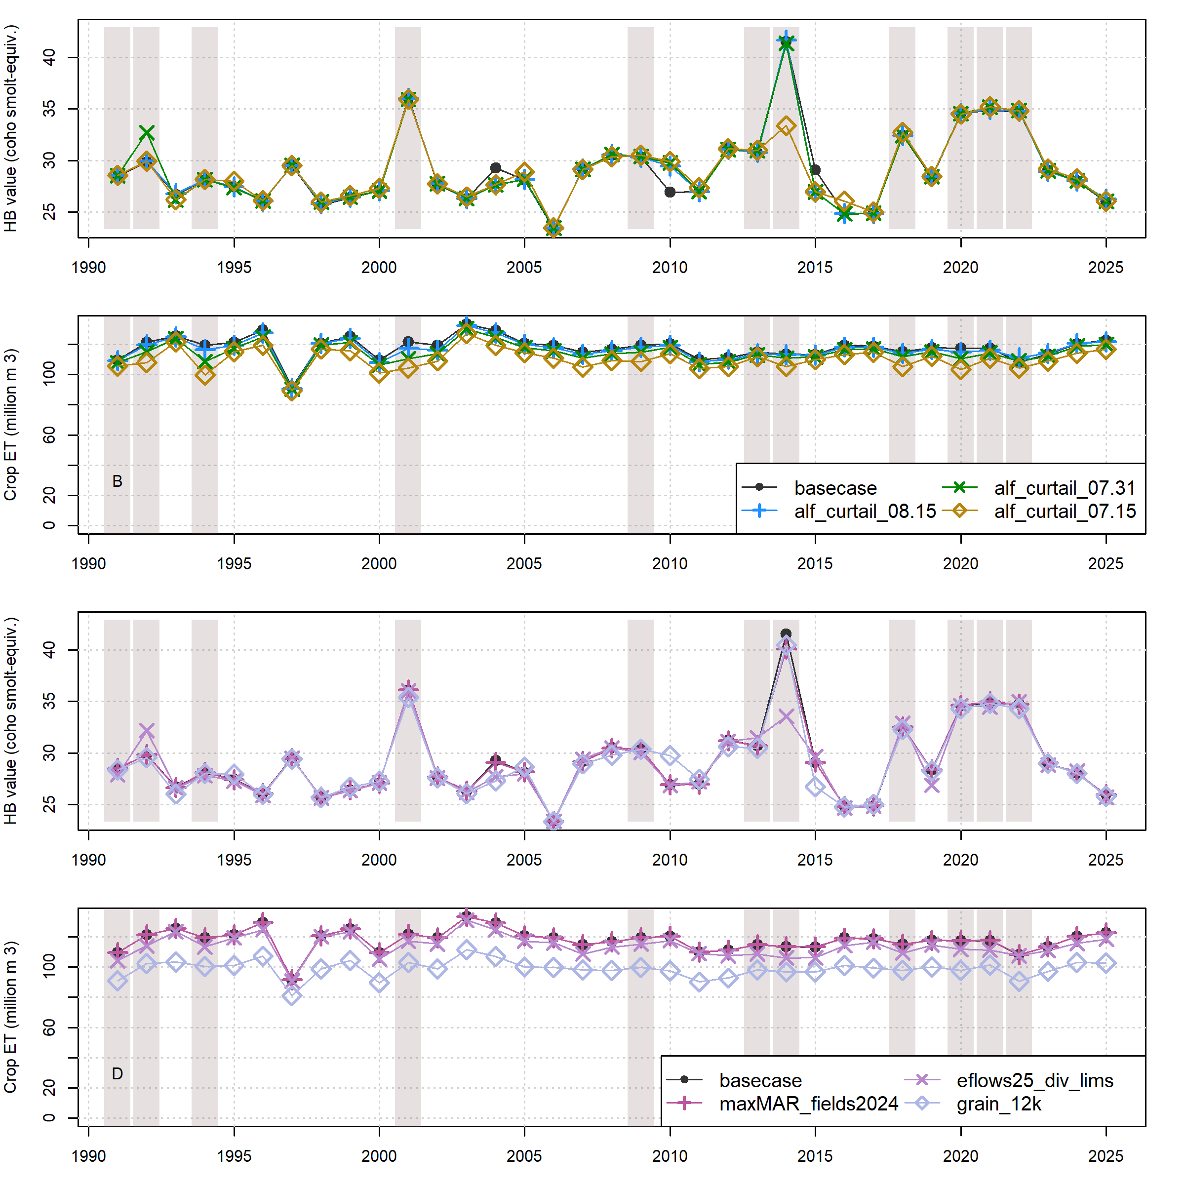
Figure 5: Comparison of annual performance in two objective functions (HB and ET, representing environmental and agricultural objectives, respectively), in the basecase (black circles) and management scenarios (diamond, cross or x symbols) for water years 1991-2025. Panels A and B show comparisons between basecase and one example scenario in each of three categories: Enhanced Recharge, Low Flow Diversion Limits, and Curtailment. Panels A and B show comparisons between basecase and different cutoff dates within the Alfalfa Irrigation category: July 15th, July 31st and August 15th. Dry-type water years (vertical bars) are 1991, ’92, ’94, 2001, ’09, ’13, ’14, ’18, and ’20-’22.
## png
## 2
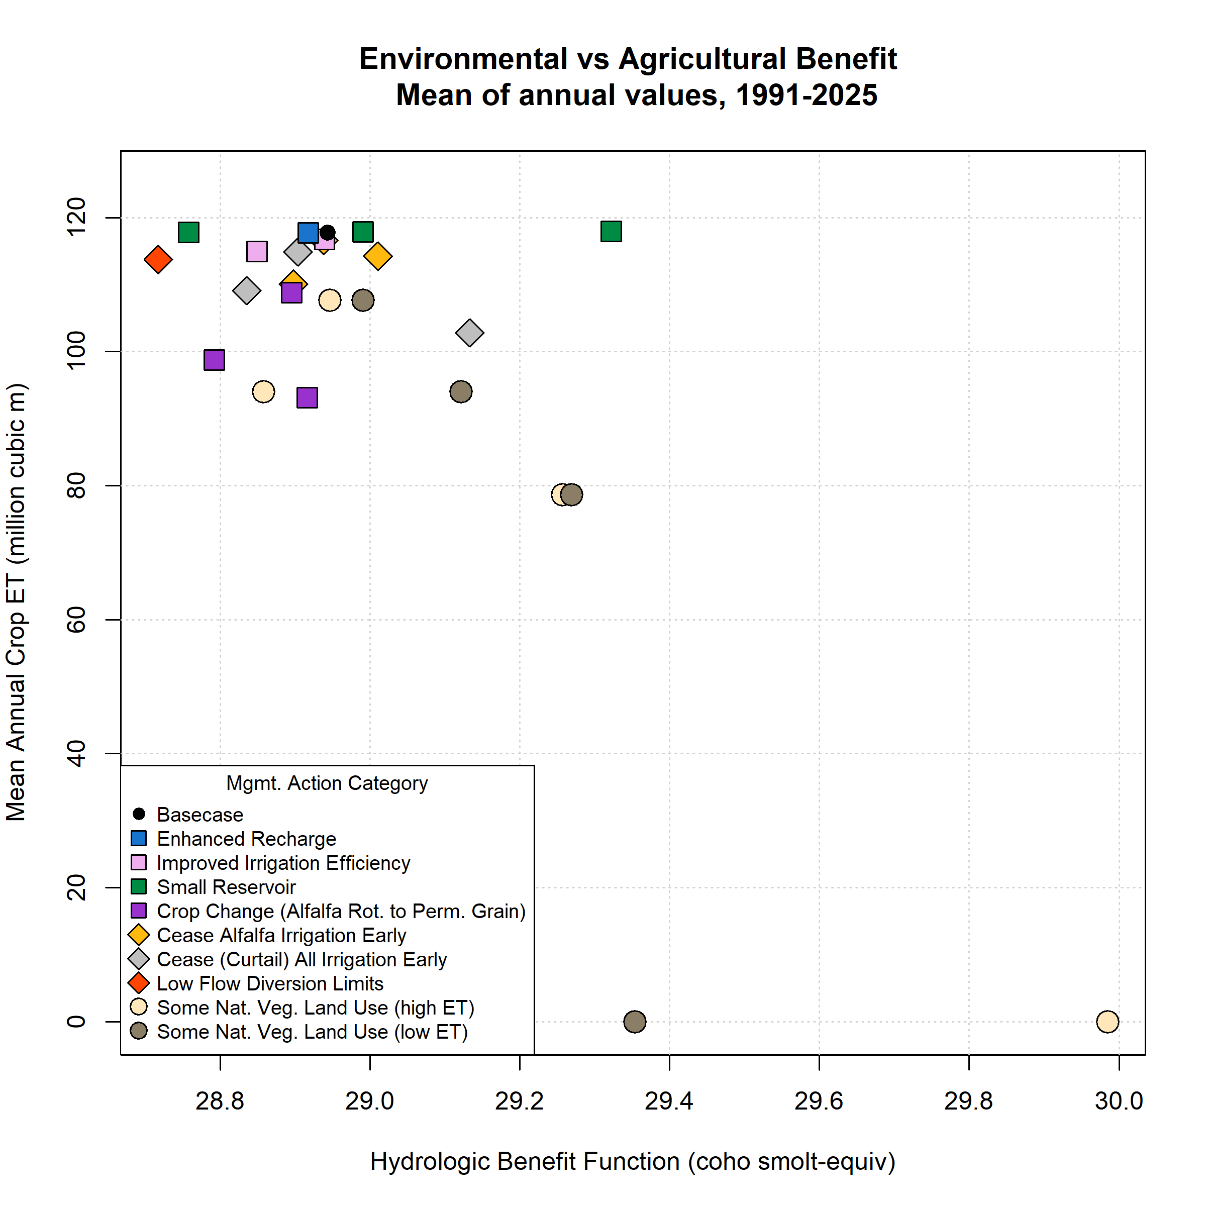
Figure 6: Environmental and agricultural objective function performance (in terms of Hydrologic Benefit, or HB, value; and crop ET volume) for basecase (black circle in upper left) and 39 management scenarios. Symbol x and y coordinates are the average of 28 annual HB and ET values for each scenario over the full model period (water years 1991-2018). Whiskers show standard error of the 28 years of annual HB values; standard errors in the direction of the y-axis are smaller than the height covered by each symbol.
## png
## 2
The aggregate hydrologic impact of each management scenario can be compared against the historical basecase using the annual objective function values over the full 28-year record (e.g., Figure 5) or using the 28-year mean values for each scenario (Figure 6; Table 5). In the basecase scenario, the 28-year mean annual ET volume is 118 million m³ of water, and the 28-year mean of annual HB values is 28.9 coho spf-equivalent (Table 5). Annual ET volume is relatively stable over the model period of water years 1991-2018, while annual HB values are much more variable (Figure 5). Among the 39 management scenarios, mean ET values ranged from 0 to 118 million m³ of water, while HB values ranged from 28.7 to 30 coho spf-equivalent.
Four scenario categories fall in a cluster with relatively high ET values, indicating that these scenarios conserve nearly all the basecase economic benefits for local growers: Enhanced Recharge, Expanded Enhanced Recharge, Irrigation Efficiency, and Small Reservoir (Figure 6). The scenarios in this group all require some degree of infrastructure investment, and they have a minimal impact on crop ET: the mean ET values of scenarios in this cluster are 118 to 118 million m³, or 0 percent less to 0.2 percent more than basecase. Their mean improvement in HB values over the basecase ranges from 0 to 0 coho spf-equivalent.
The mean ET volumes of the two Crop Change scenarios fall below those in the aforementioned cluster, with and million m³, while HB values are and respectively (Figure 6). In these scenarios, existing crop coefficients are multiplied by a factor of 0.8 or 0.9; conceptually, this would involve replacing all existing irrigated acreage with unspecified crops which had a designated 80% and 90% of historical ET demand. As discussed later, in this scenario the relationship between water use and revenue may be distinctly different from that of alfalfa and pasture, so the actual “farmer benefit” may be higher or lower than this proxy suggests.
Two regulatory management categories, Alfalfa Irrigation and Curtailment, involve irrigation schedule changes, and result in a range of reductions in applied irrigation volume, depending on the date of intervention. The scenarios in these categories trace two trade-off arcs in average HB-ET space (Figure 6). The first category, early cessation of alfalfa irrigation (during all or only dry water years), is intended to simulate growers harvesting two cuttings only (i.e., one or two fewer cuttings than current) in a given year. This was simulated by ceasing alfalfa irrigation earlier in the growing season (with cutoff dates on July 10, August 1 and August 15) than the basecase default date of Sept. 1. (The Sept. 1 cutoff date assumes that growers obtain three cuttings, but does not incorporate the known small number of growers which occasionally irrigate longer to obtain a fourth cutting.) Alfalfa acreage is concentrated near the Scott River channel, much of it in the Adjudicated Zone (Figure 1), with predominately groundwater irrigation sources. The second regulatory category, Curtailment of all irrigation starting on a range of dates (June 1st through August 15th), represent book-end scenario simulations to approximate regulatory actions proposed by state resource management agencies in response to extreme drought conditions (SWRCB 2021). The mean ET values of scenarios in these two categories are 103 to 117 million m³, or 13 to 1 percent less than basecase; HB gains over basecase are 0 to 0 coho spf-equivalent.
The third regulatory category, Low Flow Diversion Limits, regulates surface water diversion for irrigation, and contains only one scenario (Figure 6). Among all scenarios, it is the only scenario that focuses solely on management of surface water diversions for irrigation. It assumes the FJ Gauge flowrate is representative of watershed conditions, and limits diversions of surface water from all tributaries on days when the FJ Gauge flowrate falls below a recently proposed instream flow regime that is considered to be protective of anadromous fish in the Scott River (CDFW 2017). Under this Low Flow Diversion Limits scenario, the mean crop ET volume is 4 million m³ (~3%) less than basecase, while the mean HB value is 0 coho spf-equivalent greater than basecase.
The remaining two categories, abbreviated as “NatVeg” and “NatVegET”, relate to land cover type and are not proposed as management actions. Rather, these provide reference scenarios for conditions in some or all parts of the valley that could be considered to stand in for undefined “pre-historic”, “unimpaired”, or “conservation” conditions. They involve simulating native vegetation in place of irrigated acreage, and were designed to estimate the streamflow depletion attributable to agricultural water use in different areas of Scott Valley. These scenarios produce substantial HB gains at a high ET cost relative to basecase (Figure 6).
The key geographic feature in the NatVeg and NatVegET scenarios is the “Interconnected Zone” in the 1980 Scott Valley surface water adjudication (California State Water Resources Control Board 1980), referred to here as the “adjudicated zone” of groundwater pumping (Figure 1), and the six scenarios in each category represent the cessation of all irrigation or the cessation of only groundwater pumping in three spatial configurations: within the adjudicated zone, outside of the adjudicated zone, or in both areas. All areas where irrigation or pumping is turned off are assumed to return to (unirrigated) native vegetation.
On average, area-normalized ET from native vegetation is 36 cm/year (42% of average annual crop ET). Simulating native vegetation in place of irrigated acreage results in a greater proportion of water leaving the SVIHM model domain via surface flows rather than as transpiration. Consequently the NatVeg and NatVeg ET scenarios generate higher simulated FJ streamflow in most months of the model period. The first category (NatVeg) assumes a native vegetation crop coefficient of 0.6, while the second category (NatVegET) assumes a native vegetation crop coefficient of 1.0 and a maximum rooting depth of 4.5 m. The first category could be interpreted as chaparral or sage scrub-type vegetation cover, while the second category could represent a mixed bunchgrass and clover prairie with extensive riparian vegetation corridors and wetlands. (See Supplemental Material for more details on this scenario design.)
Table 5: Scenario attributes for 25 scenarios. Units for Hydrologic Benefit (HB) value are coho smolt per female-equivalent; for ET are million cubic meters; both are averages of 35 annual values. Efficiency not calculated for scenarios with no average ET loss.
Scenario ID | Category | Feas. | Mean HB / 1.000 | Mean ET | Pareto | Efficiency
basecase | basecase | 0 | 0.03 | 117.76 | Yes | --
alf_curtail_07.15 | AlfIrr | 1 | 0.03 | 110.09 | -- | --
alf_curtail_07.31 | AlfIrr | 1 | 0.03 | 114.26 | Yes | 0.08
alf_curtail_08.15 | AlfIrr | 1 | 0.03 | 116.61 | -- | --
curtail_all_07.15 | Curtail | 1 | 0.03 | 102.83 | Yes | 0.05
curtail_all_07.31 | Curtail | 1 | 0.03 | 109.13 | -- | --
curtail_all_08.15 | Curtail | 1 | 0.03 | 114.91 | -- | --
eflows25_div_lims | FlowLims | 1 | 0.03 | 113.75 | -- | --
grain_12k | CropCh | 2 | 0.03 | 98.75 | -- | --
grain_14k | CropCh | 2 | 0.03 | 93.16 | -- | --
grain_6k | CropCh | 2 | 0.03 | 108.81 | -- | --
irr_eff_0.1 | IrrEff | 2 | 0.03 | 116.74 | -- | --
irr_eff_0.2 | IrrEff | 2 | 0.03 | 114.98 | -- | --
maxMAR_fields2024 | EnhRch | 3 | 0.03 | 117.75 | -- | --
natveg_high_12k | NatVegH | 2 | 0.03 | 78.66 | Yes | 0.03
natveg_high_4k | NatVegH | 2 | 0.03 | 107.70 | -- | 0
natveg_high_8k | NatVegH | 2 | 0.03 | 94.02 | -- | --
natveg_high_all | NatVegH | 2 | 0.03 | 0.00 | Yes | 0.04
natveg_low_12k | NatVegL | 2 | 0.03 | 78.66 | Yes | 0.03
natveg_low_4k | NatVegL | 2 | 0.03 | 107.70 | -- | 0.02
natveg_low_8k | NatVegL | 2 | 0.03 | 94.02 | -- | 0.03
natveg_low_all | NatVegL | 2 | 0.03 | 0.00 | Yes | 0.01
reservoir_etna | Res | 4 | 0.03 | 117.87 | Yes | --
reservoir_french | Res | 4 | 0.03 | 117.84 | Yes | --
reservoir_shackleford | Res | 4 | 0.03 | 117.98 | Yes | --

4.2 Agricultural-environmental trade-off efficiency
The trade-off efficiency between the environmental and agricultural objective functions is defined as the average HB value gained, relative to HB_{basecase}, per ET value lost relative to ET_{basecase} (see formula in Methods). However, six scenarios (the five reservoir scenarios and managed aquifer recharge, or MAR) actually resulted in an average ET volume slightly greater than the basecase, and so avoided any ET cost. These scenarios were excluded from the efficiency calculations because including them would produce nonsensical negative efficiencies.
For all other scenarios, trade-off efficiencies ranged from -22.2 to 0.1 when averaged over all years(Table 5). The range covers two orders of magnitude because the denominator of the ratio, lost ET, ranges from 0% to 100%, while the HB gains fall more narrowly between -0.8% to 3.6%. Efficiencies greater than 1 indicate that a scenario produces more than a 1% increase in HB value per 1% loss in ET value. However, because the HB and ET units are non-commensurable, the absolute value of the trade-off efficiency is not of great significance; the trade-off efficiency metric is most useful for scenario comparisons.
Four scenario categories form a “low-efficiency” cluster, with all-years efficiencies of less than 1: Crop Change, Curtailment, and the two Natural Vegetation categories (Figure 7). These scenarios can produce substantial HB gains (ranging from 0 to 1) coho spf-equiv., but result in severe agricultural productivity reductions (-0.3% to 100%). The “high-efficiency” scenarios, which have an all-years trade-off efficiency greater than 1 (the Enhanced Recharge, Low Flow Diversion Limits, Irrigation Efficiency and Alfalfa Irrigation scenarios), tend to be associated with a small ET cost relative to basecase (-0.1 to -0.1 million m³, or -0.1 to -0.1 percent of basecase crop ET).
## png
## 2
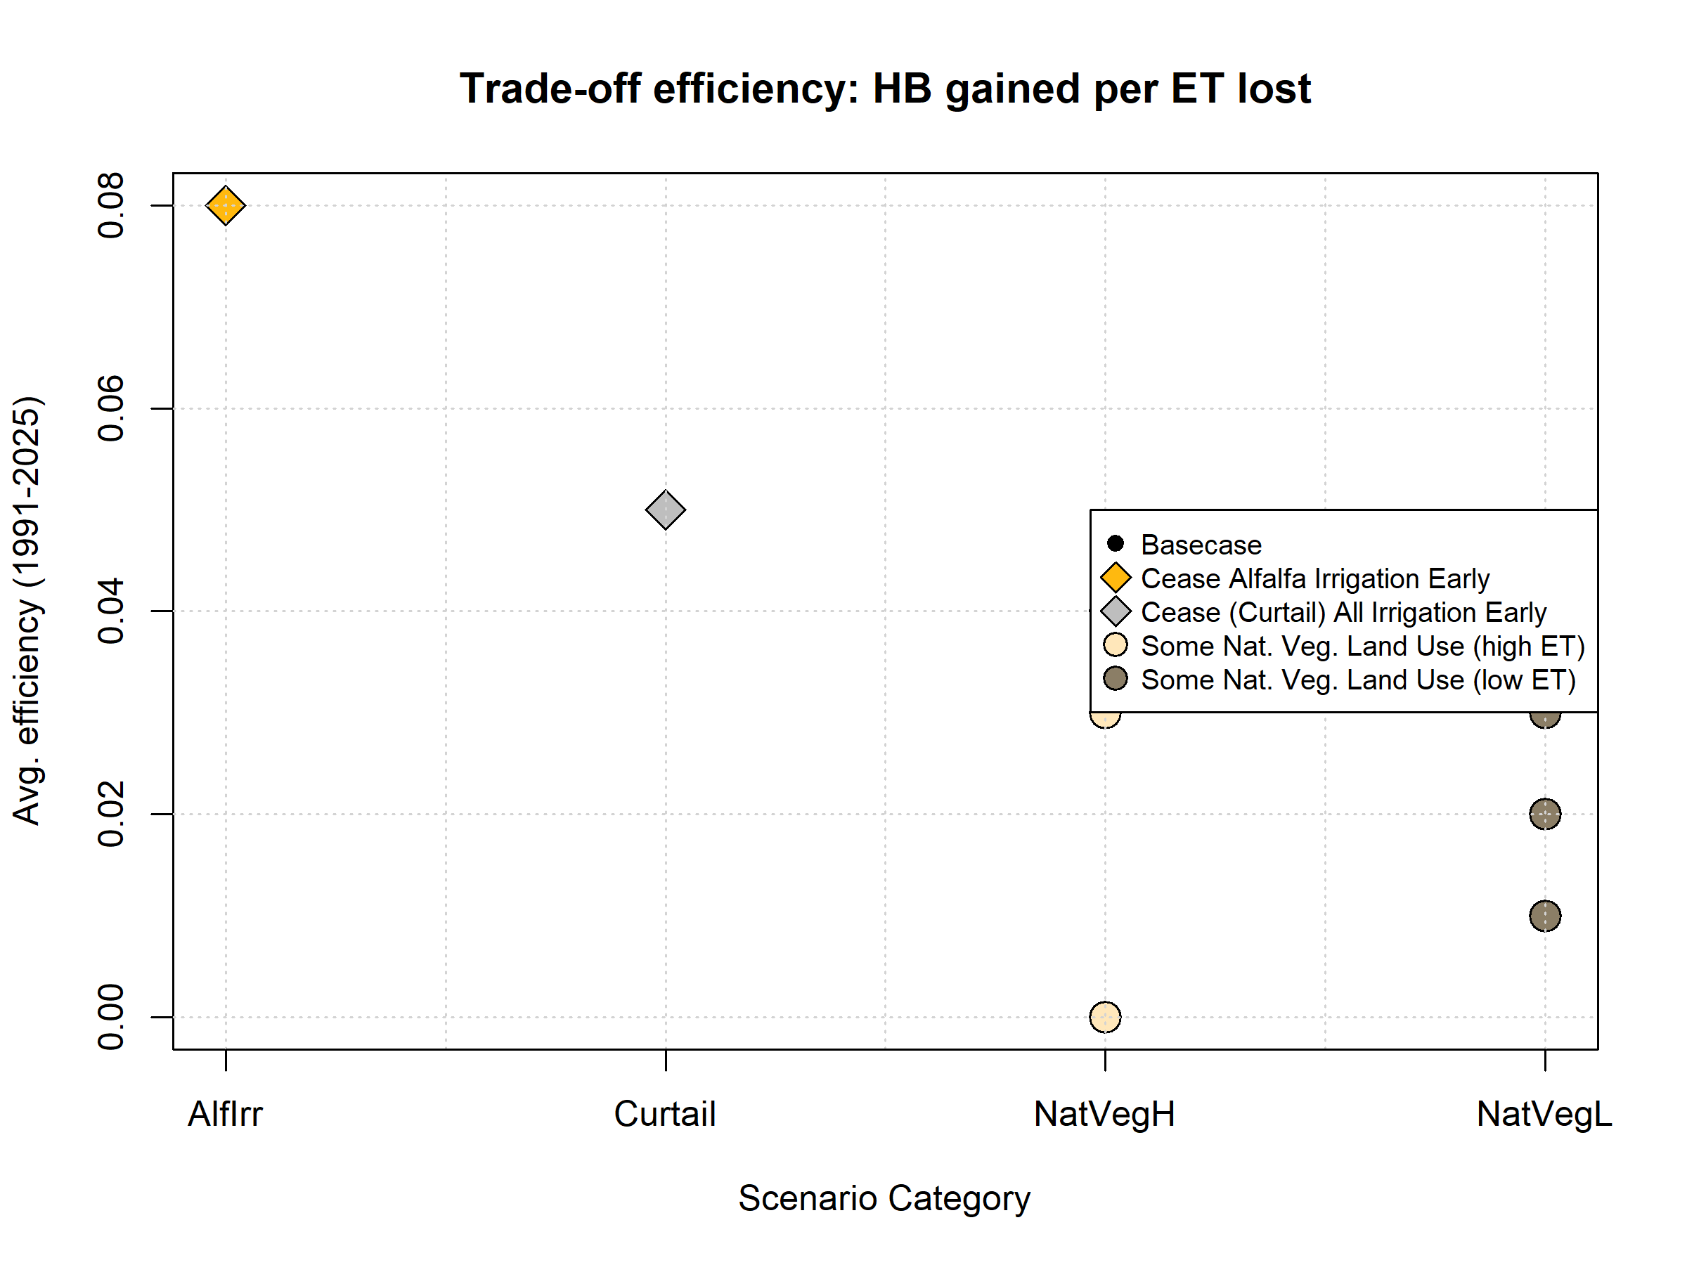
Figure 7: Scenario trade-off efficiencies, or average HB value (a proxy for environmental benefit) gained per crop ET value lost (a proxy for farmer cost) (normalized to average basecase HB and ET values, respectively), in all 35 years. Basecase, Reservoir scenarios and Enhanced Recharge scenarios are not included as they have on average no or negative ET loss, producing infinite or negative efficiency values.

4.3 Infrastructure objective, Pareto-optimal set and GSP priorities
By plotting the environmental, agricultural, and infrastructure objectives in a three-dimensional scatterplot, it is possible to visualize the combined set of management scenarios as four different trade-off arcs in different infrastructure categories (Figure 8).
The Pareto-optimal set of management actions include more than half (25) of the simulated scenarios (Table 5; Figure 8). All the suboptimal scenarios are in infrastructure category 2 (infrastructure timeline of 1-2 years). The suboptimal set are either related to land use change (Crop Change, NatVeg, and NatVegET), which reduce crop ET demand or irrigated acreage, or they involve deployment of more efficient irrigation (Irrigation Efficiency), which has little impact on either HB or ET values.
Infrastructure category 1 (no infrastructure investment needed) contains all the Regulation-type scenarios. In the Alfalfa Irrigation and Curtailment scenario categories, the trade-off arcs show the effect of intervention date: an earlier date of intervention (irrigation cutoff) produces a greater HB value at a higher ET cost, compared to a later date of intervention. The scenarios in infrastructure categories 3 and 4 (infrastructure timeline of 3-5 and 5+ years) involve no or minimal ET cost, and a range of HB gains on the middle-to-lower end of the HB gain spectrum (Reservoirs, Enhanced Recharge, and Expanded Enhanced Recharge; Figure 6).
To determine if the strict application of objective functions would produce different management priorities than the public policy development process that took place 2018-2021, we made a high-level, conceptual comparison of the Pareto-optimal set of management actions and the management actions and projects listed for consideration in the GSP (Siskiyou County 2021). Management actions considered in the GSP have some analogs in the set of 25 simulated scenarios.
High-priority scenarios tend to be associated with higher average crop ET values and modest HB gains relative to basecase (Table 6); i.e., the GSP priorities demonstrate a preference for management actions with high trade-off efficiencies. Specifically, Enhanced Recharge and Irrigation Efficiency are represented in Tiers I and II, signifying they are considered implementable in the short- or medium-term. Another high-efficiency scenario, Low Flow Diversion Limits, is represented three times in Table 6: the two analogs for it in Tier I are limited either in time (Water Trust Leasing, which occurs opportunistically in extreme droughts) or in space (the current two-creek extent of the existing watermaster program). An expanded watermaster program, which would more closely resemble the Low Flow Diversion Limits scenario, appears in Tier III.
The final high-efficiency scenario category, Alfalfa Irrigation, is not included in the list of management actions; conversely, low-efficiency scenarios in categories NatVeg and Crop Change were included, in a spatially-limited form, in Tier II under the umbrella of “Voluntary Managed Land Repurposing”. This indicates that political considerations not currently included in the three objective functions produce a preference for some amount of land repurposing rather than imposing limitations on alfalfa irrigation.
Notably, direct comparisons between the set of simulated scenarios and the management actions listed in the GSP are somewhat limited. The primary reason for this is that the simulated scenarios assume that all water users in the valley are acting in concert. Conversely, management actions included in the GSP generally assumed voluntary/incentivized participation by individual landowners in scenarios involving land use change, and in some cases are located only in specific sub-areas of the watershed.
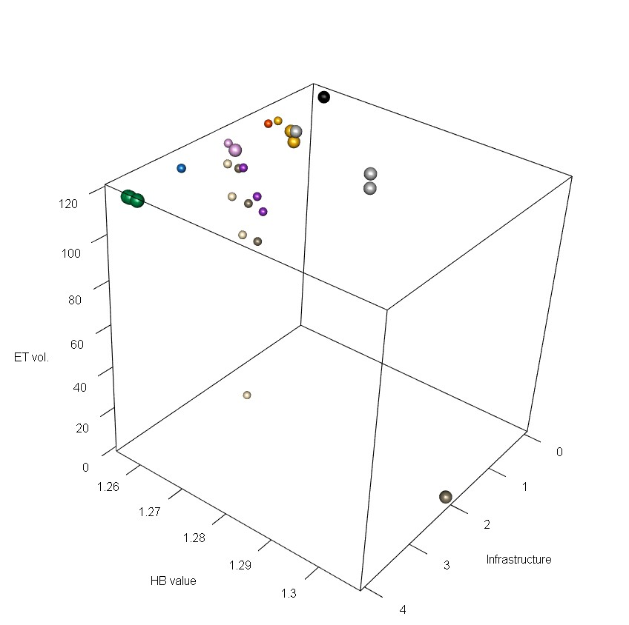
Figure 8: A three-dimensional scatter plot of the objective function values for basecase and 39 management scenarios, averaged over 28 water years (1991-2018). Larger spheres are shown for the Pareto-optimal set of scenarios. Scenario colors correspond to legend in Figures 6 and 7.
Table 6: List of management actions in Chapter 4 of the GSP and analogues in the set of 25 simulated scenarios. The Tier indicate the priority given to each management action, though the Tier also incorporates information about difficulty of implementation (hence Reservoirs being placed in Tier 3).
Tier | GSP Management Action | Closest Simulated Analogue | HB Range | ET Range
I | Watermaster Program (two creeks) | Low Flow Diversion Limits (FlowLims) | 28.72 | 114
I | Scott River Water Trust Leasing Program | Low Flow Diversion Limits (FlowLims) | 28.72 | 114
I | Irrigation Improvements | Improved Irrigation Efficiency (IrrEff) | 28.85-28.94 | 115-117
II | Irrigation Efficiency Improvements | Improved Irrigation Efficiency (IrrEff) | 28.85-28.94 | 115-117
II | MAR & ILR - NFWF  Scott Recharge Project | Enhanced Recharge (Enh- Rch) | 28.92 | 118
II | MAR & ILR | Enhanced Recharge (Enh- Rch) | 28.92 | 118
II | Voluntary Managed Land Repurposing | Possibly Crop Change (CropCh) and possibly some amount of Natural Vegetation Land Use (NatVegH or L) | 28.79-29.98 | 0-109
III | Alternative, lower ET crops | Crop Change (CropCh) | 28.79-28.92 | 93-109
III | Floodplain Reconnection/ Expansion | Enhanced Recharge (Enh- Rch) | 28.92 | 118
III | Reservoirs | Small Reservoir (Res) | 28.76-29.32 | 118-118
III | Strategic Groundwater Pumping Curtailment | Possibly Cease Alfalfa Irrigation Early (AlfIrr); Possibly Curtail Irrigation Early (Curtail) | 28.84-29.13 | 103-117
III | Watermaster Program (expanded) | Low Flow Diversion Limits (FlowLims) | 28.72 | 114

5 Discussion
add discussion of alternative env obj functions: Chinook salmon, indices of alteration
The portfolio of scenarios proposed by stakeholders and simulated for this study included a range of infrastructure investments, regulatory actions and major land use changes. The number and diversity of simulated scenarios was made possible by a surface- and groundwater model designed to approximate existing land use and agricultural water use behavior in the local context [SVIHM; Tolley, Foglia, and Harter (2019)]. Though the ultimate future effect of these management actions would depend on climate variability and implementation details that have not been explicitly simulated (e.g., the precise location of pumps needed to divert surface water for the expanded enhanced recharge scenarios), it is possible to use objective functions and historical climate records to draw some high-level findings regarding their relative merits.

5.1 Contextualizing low objective function values
The HB function incorporates several hydrologic metrics, but years with low HB values (i.e., low predicted coho-spf equivalent) usually share several characteristics.
A water year with a low HB value (e.g., < XX coho spf-equiv.) commonly occurs after a dry season with multiple dried-out mainstem Scott River reaches, culminating in a prolonged fall period (e.g., 4 to 8 weeks after September 1st) of FJ Gauge flows lower than 10 cfs. In a low-HB water year, high winter baseflows (e.g., > 200 cfs) may not arrive until December or January, and the rainy season may be short (e.g., < 100 days). These hydrologic features have implications for fishery stability. In water year 2014, for example, salmon access flows were significantly delayed, and coho salmon laid their eggs in the mainstem of the Scott River rather than in their preferred tributary stream habitat, which put them at higher risk of getting scoured away in a winter storm (CDFW 2015).
Because no recent precedent exists for a low-crop-ET year, interpreting the numerical values of the ET objective function requires more speculation, and the specific impact of ET loss on the agricultural community depends on the specific management action and its enforcement. One method to address uncertainty related to impact of management actions on agricultural objectives is to survey regional agricultural practitioners and experts about the likely costs of a proposed management action (Sunding 1996). In the public meetings during GSP development, some informal (i.e., non-quantitative) surveying of stakeholder expectations of the costs of management actions took place. In terms of operational impacts, Scott Valley agricultural stakeholders stated that short-term interventions (such as fallowing an alfalfa field for one year, or curtailing pasture irrigation for a growing season) could have long-term impacts (such as affecting alfalfa yield the following year, or forcing a rancher to sell a herd (SVGAC 2021). The current agricultural benefit proxy, annual crop ET, does not capture these multi-year costs to the local agricultural sector, or the regional impact that reduced agricultural productivity will have on economically disadvantaged local communities.
These predicted on-the-ground consequences can facilitate interpretation of scenario results.

5.2 Environmental objective performance in historically low-coho years
Management scenario performance in dry years, rather than over the whole model period, is another informative metric for resource managers. For example, in potentially unstable fish populations, conditions during critical dry years can be more significant than long-term average conditions (e.g., Ohlberger et al. 2018). Eight dry years occurred during the 1991-2018 model period: 1991, ’92, ’94, 2001, ’09, ’13, ’14, and ’18 (Figure 5). Dry years were classified using quartiles of the distribution of total annual FJ Gauge flow over the full record of water years 1942-2021. The lowest to highest quartiles of total annual flow are classified as Dry, Below Average, Above Average, and Wet water year types, respectively.
However, in this system, the years following dry periods may be more informative. As mentioned in Methods, the lowest basecase HB values, operationally defined here as years with basecase HB values of less than XX predicted coho spf-equivalent, tend to occur in years following one or more dry years (i.e., 1993, 1995, 2002, and 2014-16 in Figure 5; “low-coho years”). In the Scott River watershed, one mechanism producing this pattern is delayed onset of winter storms, which cannot be managed through policy. Another mechanism is the depletion of stored groundwater in dry years, which can reduce dry-season baseflow and delay stream system reconnection during the onset of the following wet season (Tolley, Foglia, and Harter 2019). Regardless of the primary cause of the low fall flows in a particular year, the HB value for each water year is sensitive to long periods in the fall with flow below 10 and 100 cfs (see Chapter 1 of this dissertation for more details on coho salmon sensitivity to low fall flows).
Because many aspects of scenario performance are relatively consistent (i.e., for any given scenario, ET costs are relatively static year to year, and most scenarios demonstrate consistently small HB gains over basecase in high-coho spf years; Figure 5), the low-coho year HB performance of various model scenarios is a key scenario differentiator.

5.3 Environmental-agricultural trade-offs
Balancing agricultural and environmental water demands in this watershed commonly takes the form of seeking management actions that can improve flow conditions while minimizing the resulting reduction in agricultural water availability. Consequently, a subset of the proposed scenarios rely on infrastructure investments to produce modest HB improvements with minimal-to-no ET reductions (Enhanced Recharge, Expanded Enhanced Recharge, Irrigation Efficiency, and Reservoirs) (Figure 6). The remaining categories tend to include some level of ET reduction, due to reduced water availability for irrigation.
The environmental gain-agricultural cost trade-off is evident both within individual categories and between distinct scenario categories, especially in HB performance in low-coho years.
Among Alfalfa Irrigation scenarios, and ET costs are small (averaging 1 and 3 million m³, respectively, in all years); conversely, the more extreme July 10th cutoff date produces an average of 8 million m³, or 7%, reduction in ET in all years (panels A and B of Figure 5).
Trade-off is also evident between scenario categories. The Enhanced Recharge scenario mar_ilr has a minimal ET cost (an average of 0 million m³ less than basecase in all years). At the other extreme, the Curtailment scenario in which all irrigation is cut off on August 1st (curtail_start_07.31), but reduces ET by an average of 9 million m³ or 7% (panels C and D of Figure 5). Compared to curtail_start_07.31, the Low Flow Diversion Limits (flowlims) scenario reduces ET by an average of 3%.
The 33 scenarios with ET lower than basecase sort clearly into one high- and one low-efficiency cluster (Figure 7). The high-efficiency scenarios are composed of three infrastructure-type management actions (Enhanced Recharge, Expanded Enhanced Recharge and Irrigation Efficiency) and two regulatory-type management actions (Alfalfa Irrigation and Low Flow Diversion Limits), while the low-efficiency group contains one infrastructure-type (Crop Change), one regulatory-type (Curtailment), and the two native vegetation-type scenarios. The previously-stated caveat regarding the Crop Change scenario’s true agricultural benefit potentially being higher or lower than the values in Table 5 apply to these efficiency calculations as well. The trade-off efficiencies provide an informal cost-benefit assessment, though interpretation is somewhat limited, as the unitless quantity tends to group together scenarios with widely varying absolute values of HB and ET (e.g., Crop Change and some Curtailment scenarios).
There is a clear positive relationship between efficiency in all years and in low-coho years, but in nearly all scenarios the low-coho year efficiency average is higher than over the 28-year model period (Figure 7). In other words, in low-coho years, a given amount of crop ET reduction produces a greater environmental flow enhancement than on average over all years. This is corroborated by annual scenario HB values: in high-coho years, HB gains are small or minimal, while substantial improvements are seen for some scenarios in low-coho years (panels A and C in Figure 5). One possible explanation is that, in high-coho years, environmental flows tend to already be sufficient, and most management scenarios can generate only marginal improvements in hydrologic conditions. This suggests that targeting management actions to dry years (which tend to precede the low-coho water years) may produce the highest efficiency management actions. This possibility was supported by the two cases where this comparison was explicitly simulated: the efficiencies for the Alfalfa Irrigation scenarios for dry years only (alf_irr_stop_07.31_dry_yrs_only and alf_irr_stop_08.15_dry_yrs_only) are higher than for their corresponding scenarios with an intervention in all years (alf_irr_stop_07.31 and alf_irr_stop_08.15; Table 5).

5.4 Pareto-optimal solution set and GSP priority management actions
Within the proposed suite of management actions, more than half (25 of 25, including the basecase) fall within the Pareto-optimal set based on the infrastructure category and the 28-year average values of objective functions. This same set remains Pareto-optimal when the objective functions are averaged only over the six low-coho water years, with one exception (the French Creek reservoir scenario is Pareto-optimal when averaged in all years, but not in low-coho years).
The non-Pareto-optimal scenarios (i.e. the scenarios outperformed in multiple objectives) are in the Irrigation Efficiency, Crop Change and Native Vegetation categories. (The 20% improved Irrigation Efficiency scenario is outperformed in both HB and ET objectives by both of the alfalfa irrigation scenarios with a cutoff date of August 15; Table 5). Native Vegetation scenarios, under two different assumptions about vegetation type/ET demand of the vegetation replacing cultivated agriculture, can produce significant HB improvements, but at a relatively high cost in regional agricultural productivity; these two scenario categories have the lowest trade-off efficiency (Figure 7; Table 5).
Pareto-suboptimal status is less certain in the case of the Crop Change scenario, since the ET volume proxy for agricultural revenue/benefit may not be valid for alternative crops. (Crops that have been mentioned during stakeholder meetings as possibly suited to the climate of Scott Valley or have been cultivated in a trial setting are high(er) value annuals in lieu of the current perennial crops, e.g., potatoes, sunflowers, and carrots for seed, though notably, to the authors’ knowledge no local grower has cultivated any of these commercially.)
Many of the simulated scenarios were included in the ultimate list of management priorities in the adopted GSP (Siskiyou County 2021), though in a variety of forms (e.g., the Low Flow Diversion Limits scenario, which is the closest simulated analogue for a watermaster program and a surface water leasing program; Table 6). Although the GSP management priorities emphasized infrastructure, in a strict application of these objective functions, both infrastructure-based and regulatory approaches fell within the Pareto-optimal set of management options.

5.5 Policy implications
Although the HB values are based on well-studied hydro-biological relationships (late spawning flows leads to lower fishery reproduction rates), the actual predicted values of coho smolt production per female spawner (coho spf) remain uncertain, because when the HB function was developed only 11 full years of coho spf data were available. If monitoring continues in future years and this sample size increases, the predictive power and weights of various hydrologic metrics may be reexamined. The ET values are estimated based on climate data, crop coefficients, and assumptions regarding grower decisions, and thus are subject to uncertainty in those data sources.
Due to this uncertainty, the results of this study should not be considered direct policy recommendations. However, some of the insights below could be used to support future management decisions, simply by summarizing the wealth of information provided in each model simulation using the proposed objective functions.
- Targeted interventions that only regulate water use in dry periods produce higher trade-off efficiencies than continuous interventions, as illustrated by the Alfalfa Irrigation scenarios (i.e., dry years only versus all years; Table 5).
- The Low Flow Diversion Limits scenario takes this concept to its logical extreme, by limiting intervention only to low-flow days in the hydrologic record, rather than low-flow years or seasons in the Alfalfa Irrigation category. As a result it produces considerable low-coho year HB gains with a trade-off efficiency of greater than 1.
- Key data gaps limit interpretability of some scenario results. An agronomic study of alternate crops that could be cultivated in Scott Valley, for example, could better constrain the agricultural benefits of a Crop Change scenario. Conversely, the acreage of land converted in various Native Vegetation scenarios is likely higher than any realistic land use change scenario, meaning that for a hypothetical management action involving a reduction of irrigated acreage in the valley, the HB gains and ET costs may be smaller than shown in Figure 6.
- In recent years, drought conditions have prompted state regulatory agencies to consider and then impose significant irrigation curtailments (SWRCB 2021). The objective function summary of existing model results could help stakeholders and regulators weigh the trade-offs of various actions and potential irrigation cutoff dates in the context of the consequences of other proposed management scenarios. The modeling results suggest that if a decision is made to regulate water use, some later intervention dates may produce minimal gains in environmental flows in some water years (e.g., an alfalfa irrigation cutoff date of August 15 in water years 1995 or 2002 in panel A of Figure 5).

6 Conclusion
In this study, functions quantifying the achievement of the two management objectives (environmental and agricultural) were applied to 25 simulated management scenarios (including a historical basecase). In addition, scenarios were assigned a categorical proxy for new infrastructure costs. We used these numerical values to quantitatively explore trade-offs in environmental and agricultural benefit among the suite of proposed actions.
Due to decades of investment and significant ongoing labor, aggregate agricultural productivity in Scott Valley (as estimated through crop ET) is buffered against the weather and is relatively stable year-to-year. Conversely, flow in the undammed Scott River is subject to the full range of climate variability and human water uses. As a result, the historical performance in the environmental flows objective is much more variable than in the agricultural objective, and environmental flows measured with this objective function seem particularly vulnerable to multi-year dry periods.
Many management actions were proposed over the past four years to enhance environmental flows while minimizing negative effects on agricultural water security. In general, targeting irrigation reductions during low-flow periods (e.g. Early Cessation of Alfalfa Irrigation and Low Flow Diversion Limits) tends to be more efficient in terms of higher environmental flows per lost agricultural productivity than irrigation reduction over the whole growing season, such as the Native Vegetation scenarios (Figure 7).
Objective functions summarizing the predicted consequences of management actions is not a new technique; however, to be useful in a decision support context, they require careful design, sensitivity to local conditions, and ongoing feedback from affected stakeholders. Introducing these elements of optimization into existing water resource management processes can improve communication of management consequences and priorities, and thus potentially improve decision-making and our understanding of the interconnected socio-hydrologic system.

Acknowledgments

7 References
Bork, Karrigan, and Keith Hirokawa. 2021. “Trends in Local Ecosystem Governance.” Frontiers in Climate 3 (September): 719150. https://doi.org/10.3389/fclim.2021.719150.
Brown, Larry R., Peter B. Moyle, and Ronald M. Yoshiyama. 1994. “Historical Decline and Current Status of Coho Salmon in California.” North American Journal of Fisheries Management 14 (2): 237–61. https://doi.org/10.1577/1548-8675(1994)014<0237:HDACSO>2.3.CO;2.
California Department of Fish and Wildlife. 2017. “INTERIM INSTREAM FLOW CRITERIA FOR THE PROTECTION OF FISHERY RESOURCES IN THE SCOTT RIVER WATERSHED, SISKIYOU COUNTY.”
California Department of Fish and Wildlife, NOAA-Fisheries, Scott River Water Trust, Siskiyou Resource Conservation District, and U.S. Forest Service - Klamath National Forest. 2015. “Cooperative Scott River Coho Rescue & Relocation Effort: 2014 Drought Emergency.”
California Department of Water Resources. 2017. “Statewide Crop Mapping - 2016 Statewide Crop Mapping GIS Shapefiles - California Natural Resources Agency Open Data.” 2016 Statewide Crop Mapping GIS Shapefiles. https://data.cnra.ca.gov/dataset/statewide-crop-mapping/resource/3b57898b-f013-487a-b472-17f54311edb5.
California State Water Resources Control Board. 1980. “Scott River Adjudication, Decree No. 30662. Scott River Stream System, Siskiyou County.” Superior Court of Siskiyou County.
California State Water Resources Control Board (SWRCB). 1975. “Report on Hydrogeologic Conditions, Scott River Valley, Scott River Valley.”
Carpenter, Cameron. 2024. “Accurately Identifying Functional Flow Metrics in Flashy and Highly Altered Stream Systems.” Master’s thesis, University of California, Davis.
Carter, P. R., and C. C. Sheaffer. 1983. “Alfalfa Response to Soil Water Deficits. I. Growth, Forage Quality, Yield, Water Use, and Water-Use Efficiency¹.” Crop Science 23 (4): 669–75. https://doi.org/10.2135/cropsci1983.0011183X002300040016x.
Cohon, Jared L., and David H. Marks. 1973. “Multiobjective Screening Models and Water Resource Investment.” Water Resources Research 9 (4): 826–36. https://doi.org/10.1029/WR009i004p00826.
“Establishment of Minimum Instream Flow Requirements, Curtailment Authority, and Information Order Authority in the Klamath Watershed.” 2021. {{NOTICE OF APPROVAL OF EMERGENCY REGULATORY ACTION}}.
“Establishment of Minimum Instream Flow Requirements, Curtailment Authority, and Information Order Authority in the Scott River and Shasta River Watersheds.” 2024. {{NOTICE OF APPROVAL OF EMERGENCY REGULATORY ACTION}}.
Foglia, Laura, Alison McNally, Courtney Hall, Lauren Ledesma, Ryan Hines, and Thomas Harter. 2013. “Scott Valley Integrated Hydrologic Model: Data Collection, Analysis, and Water Budget.” Davis, CA: North Coast Regional Water Quality Control Board.
Fox Canyon Groundwater Management Agency. 2019. “Groundwater Sustainability Plan for the Oxnard Subbasin.” Ventura, CA: Fox Canyon Groundwater Manegement Agency.
Freeman, David M. 2000. “WICKED WATER PROBLEMS: SOCIOLOGY AND LOCAL WATER ORGANIZATIONS IN ADDRESSING WATER RESOURCES POLICY.” Journal of the American Water Resources Association 36 (3): 483–91. https://doi.org/10.1111/j.1752-1688.2000.tb04280.x.
Harter, Thomas, and Ryan Hines. 2008. “SCOTT VALLEY COMMUNITY GROUNDWATER STUDY PLAN.” University of California, Davis.
Kapelan, Zoran S., Dragan A. Savic, and Godfrey A. Walters. 2005. “Multiobjective Design of Water Distribution Systems Under Uncertainty.” Water Resources Research 41 (11): 2004WR003787. https://doi.org/10.1029/2004WR003787.
Kouba, Claire, Leland Scantlebury, Jason Wiener, Sarah Yarnell, and Thomas Harter. 2025. “A Watershed-Specific Approach to Identify Key Functional Flow Metrics Supporting Salmon Reproduction.” Ecohydrology : Ecosystems, Land and Water Process Interactions, Ecohydrogeomorphology 18 (5): e70098. https://doi.org/10.1002/eco.70098.
Mack, Seymour. 1958. “Geology and Ground-Water Features of Scott Valley, Siskiyou County, California.” Geological {{Survey Water-Supply Paper}} 1462. United States Geological Survey. https://doi.org/10.3133/wsp1462.
Mahoney, John M., and Stewart B. Rood. 1998. “Streamflow Requirements for Cottonwood Seedling Recruitment—An Integrative Model.” Wetlands 18 (4): 634–45. https://doi.org/10.1007/BF03161678.
Monarchi, David E., Chester C. Kisiel, and Lucien Duckstein. 1973. “Interactive Multiobjective Programing in Water Resources: A Case Study.” Water Resources Research 9 (4): 837–50. https://doi.org/10.1029/WR009i004p00837.
Nordgren, John, Missy Stults, and Sara Meerow. 2016. “Supporting Local Climate Change Adaptation: Where We Are and Where We Need to Go.” Environmental Science & Policy 66 (December): 344–52. https://doi.org/10.1016/j.envsci.2016.05.006.
Ohlberger, Jan, Thomas W. Buehrens, Samuel J. Brenkman, Patrick Crain, Thomas P. Quinn, and Ray Hilborn. 2018. “Effects of Past and Projected River Discharge Variability on Freshwater Production in an Anadromous Fish.” Freshwater Biology 63 (4): 331–40. https://doi.org/10.1111/fwb.13070.
Patterson, Noelle K., Belize A. Lane, Samuel Sandoval-Solis, Gregory B. Pasternack, Sarah M. Yarnell, and Yexuan Qiu. 2020. “A Hydrologic Feature Detection Algorithm to Quantify Seasonal Components of Flow Regimes.” Journal of Hydrology 585 (June): 124787. https://doi.org/10.1016/j.jhydrol.2020.124787.
Scott River Watershed Council. 2018. “Restoring Priority Coho Habitat in the Scott River Watershed Modeling and Planning Report.”
Scott Valley Area Plan Committee. 1980. “Scott Valley Area Plan.” Siskiyou County.
Siskiyou County. 2021. “Scott Valley Groundwater Sustainability Plan.”
Siskiyou County GSA - Scott Valley Groundwater Advisory Committee. 2021. “Siskiyou County Groundwater Sustainability Agency: Scott Valley Advisory Committee Meeting.” Fort Jones, CA: Siskiyou County.
STATE WATER RESOURCES CONTROL BOARD. 2024. “RESOLUTION NO. 2024-0036: REGARDING FLOW EFFORTS IN THE SCOTT RIVER AND SHASTA RIVER WATERSHEDS.” 2024-0036.
Sunding, David L. 1996. “Measuring the Marginal Cost of Nonuniform Environmental Regulations.” American Journal of Agricultural Economics 78 (4): 1098–1107. https://doi.org/10.2307/1243866.
Tolley, D., L. Foglia, and T. Harter. 2019. “Sensitivity Analysis and Calibration of an Integrated Hydrologic Model in an Irrigated Agricultural Basin With a Groundwater-Dependent Ecosystem.” Water Resources Research 55 (9): 7876–7901. https://doi.org/10.1029/2018WR024209.
Van Steenbergen, Frank. 2006. “Promoting Local Management in Groundwater.” Hydrogeology Journal 14 (3): 380–91. https://doi.org/10.1007/s10040-005-0015-y.
Yarnell, Sarah M., Geoffrey E. Petts, John C. Schmidt, Alison A. Whipple, Erin E. Beller, Clifford N. Dahm, Peter Goodwin, and Joshua H. Viers. 2015. “Functional Flows in Modified Riverscapes: Hydrographs, Habitats and Opportunities.” BioScience 65 (10): 963–72. https://doi.org/10.1093/biosci/biv102.
Yeh, William W-G., and Leonard Becker. 1982. “Multiobjective Analysis of Multireservoir Operations.” Water Resources Research 18 (5): 1326–36. https://doi.org/10.1029/WR018i005p01326.
Yolo Subbasin Groundwater Agency. 2022. “Yolo Subbasin Groundwater Sustainability Plan.” Woodland, CA.

